**Ideation Phase**

**Define the Problem Statements**

|  |  |
| --- | --- |
| Date | 29 August 2025 |
| Team ID | LTVIP2025TMID61033 |
| Project Name | Order On The Go |
| Maximum Marks | 2 Marks |

**Customer Problem Statement Template:**

To define the core problems customers face while ordering for food items online, and use those insights to guide the development of the team.

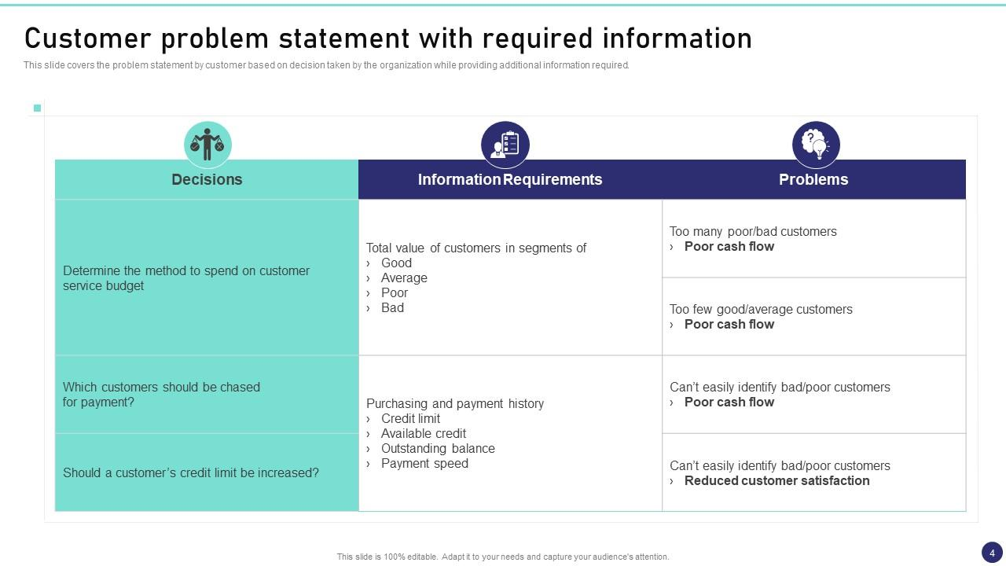

Reference: <https://miro.com/templates/customer-problem-statement/>

| **Problem ID** | **User Type** | **Context / Situation** | **Pain Point** | **Why it Matters** | **Problem Statement** |
| --- | --- | --- | --- | --- | --- |
| 1 | Busy Commuter | On the way to work, limited time | Ordering takes too long in the morning | Risk of being late, skips breakfast | A busy commuter needs a way to order breakfast quickly because waiting in line wastes precious time. |
| 2 | Parent with Kids | Managing children during errands | Difficult to place orders with distractions | Stressful, increases mistakes | A parent needs a way to order hands-free because typing while multitasking is inconvenient. |
| 3 | Frequent Customer | Reordering the same food daily | Too many steps to repeat orders | Frustration and app abandonment | A frequent customer needs a one-tap reorder feature because repeating the same process is inefficient. |
| 4 | Traveler | In a new city, unfamiliar restaurants | Hard to find nearby trusted vendors | Leads to poor choices or delays | A traveler needs location-based suggestions because they don’t know where to order quickly. |
| 5 | Health-conscious User | Wants healthier options on the go | Limited filtering of menus | Poor experience and drop-off | A health-conscious user needs personalized filters because it saves time finding the right meal. |